**First Commit – Started and created the following files – Program.cs, TriangleSolver.cs and TriangleSolverTests.cs**

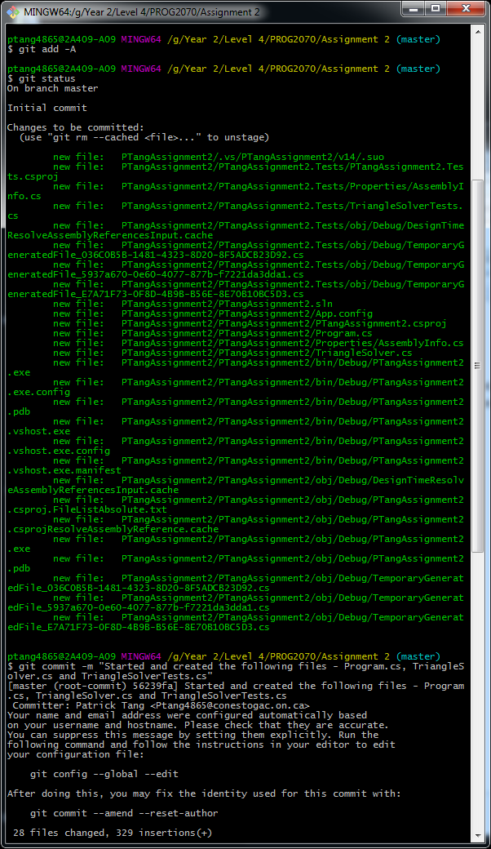

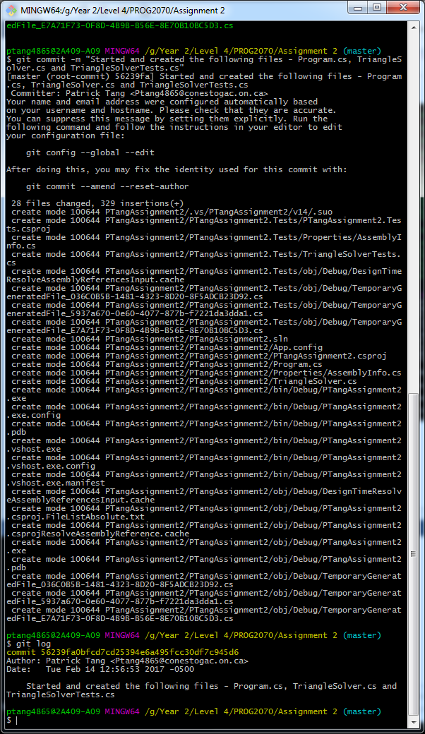

**Second Commit – Added More Code for Program.cs and TriangleSolver.cs**

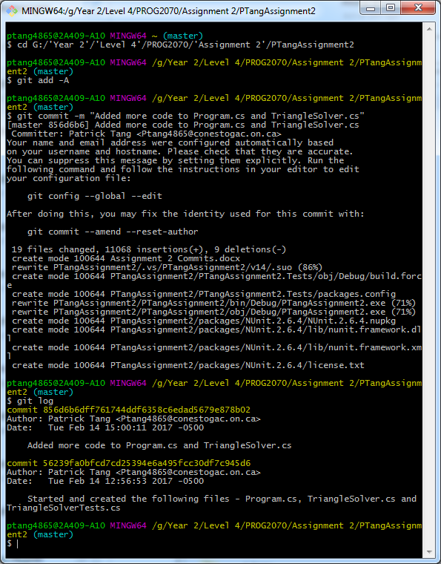

**Third Commit – Not much done, was experimenting and added some code**

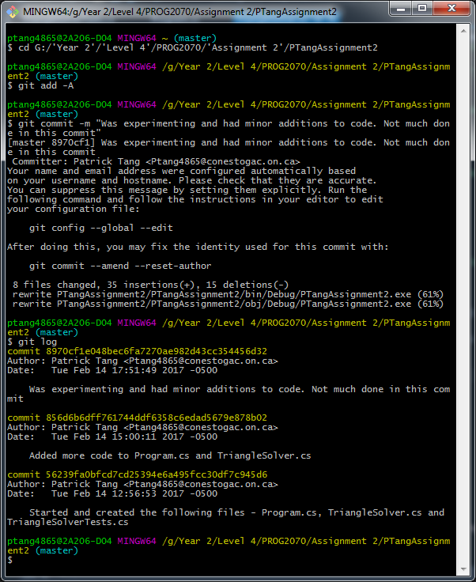

**Fourth Commit – Finished Coding the Project**

